Name : Tushar Pathak
Reg Num : 230905396
Roll Num : 6CSEB-B2

Week 10 : Databases – Part I

Q1)Design a web site using Django, which is a website directory – A site containing
links to other websites. A web page has different categories.
• A category table has a name, number of visits, and number of likes.
• A page table refers to a category, has a title, URL, and many views.
Design a form that populates the above database and displays it.
Output :
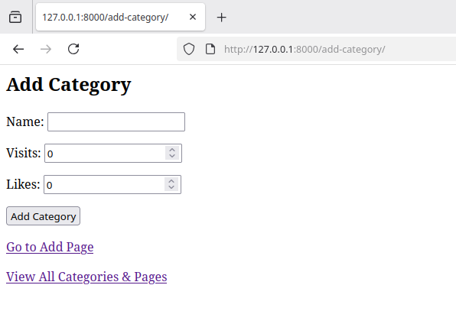
Add-Category

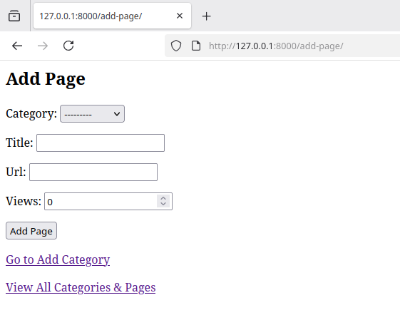
Add-Page

Show-Category And Pages Created

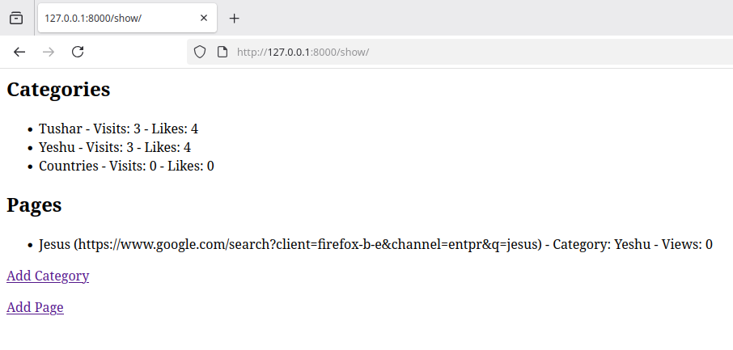
Q2) Consider the following tables:
WORKS(person-name,Company-name,Salary)
LIVES(Person_name, Street, City)
Assume Table data suitably. Design a Django webpage and include an option to
insert data into WORKS table by accepting data from the user using TextBoxes.
Also, include an option to retrieve the names of people who work for a
particular company along with the cities they live in (particular company name
must be accepted from the user).
Output:
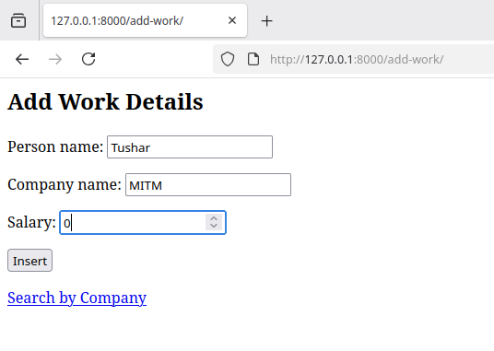
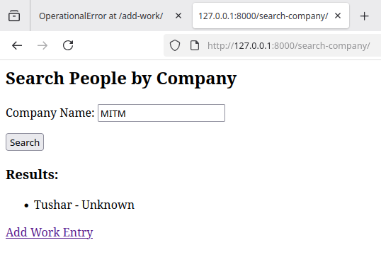
Add-Work
Search-Company, People in Company

